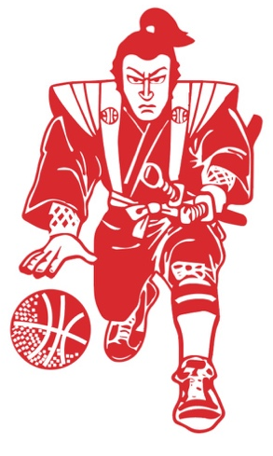
Barons 2020 reflections
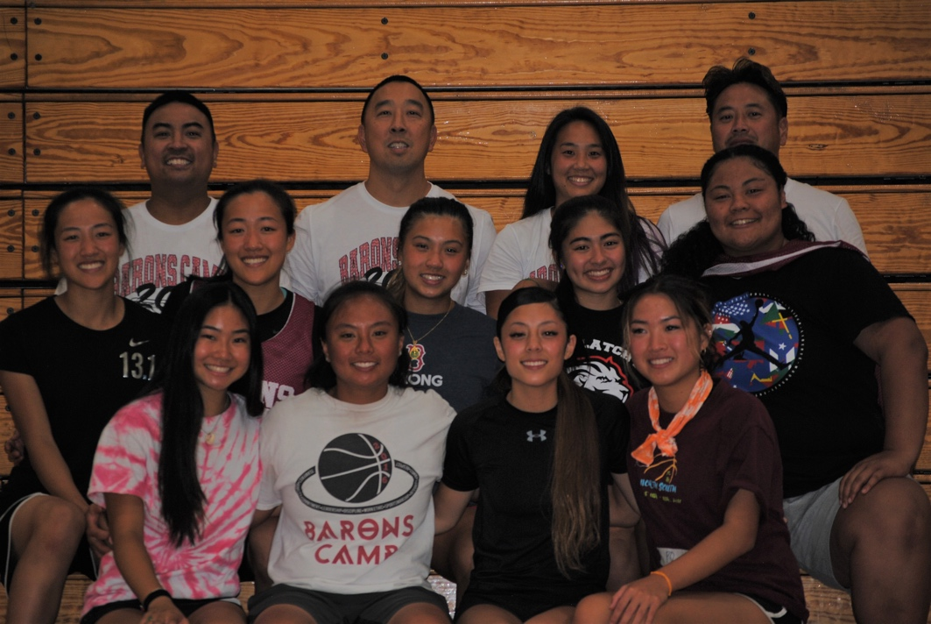

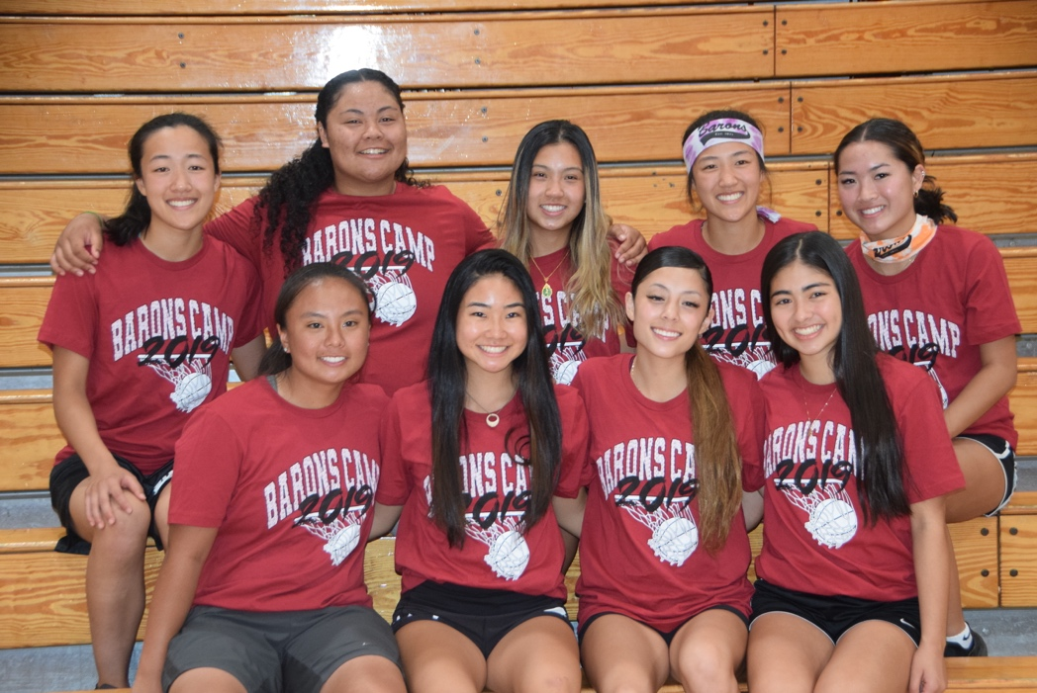

nicole fong #3

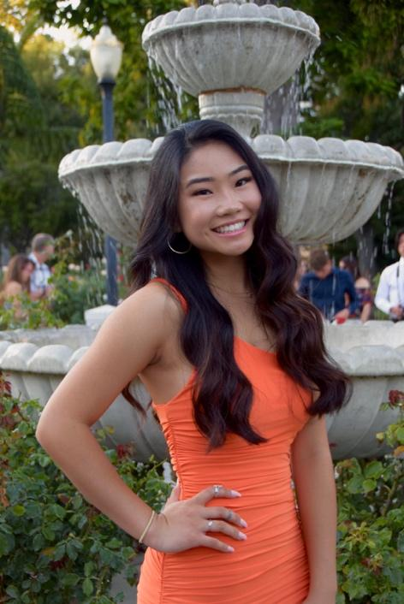
c.k. McClatchy high school
As I am nearing the end of my childhood and preparing to cross the threshold into adulthood, I am beginning to reflect on my adolescent years and all the events that made me who I am. Of course, there were birthday parties, prom, and football games, but I have concluded that my time with the Barons organization has played an integral role in shaping who I am today.

An all-star team of church ball rivals, Barons 2020—spearheaded by Coach Brandon, Coach Kimi, Coach AJ, and Coach Bryan—quickly established ourselves as the team to beat. Yet our wins were not because of one player, but because every single one of us worked together. Though over the past six years, we’ve won nearly every black t-shirt, the wins on the court have always been background noise to the camaraderie and love that saturates this team. My time was not defined by our win-loss record, but rather by the people who gave me side aches after laughing so hard. By the people I will find at my wedding, future baby showers, and all the life milestones in between. By the people I am blessed to call my family.

To my team: Sometimes I wonder what I did to deserve such an amazing group of people. Thank you for the hours upon hours of happiness you’ve given me and the tremendous love you’ve poured into my life. You truly are the sisters I always wanted, and I am cannot express to you how grateful I feel to have shared so many moments together.

Thank you Coach B., for everything. There is something about you that ignites every one of us; just your presence inspires us to do and be the best we can. We have so much respect for all you encompass, and we cannot thank you enough for your words of wisdom, hour-long life conversations before
practice, and thorough text messages that always made me tear up.

Thank you Coach AJ, for picking up right where he left off and stepping in when we needed you most. I was skeptical of a new addition to the team so late in our career. but my hesitations were destroyed upon our first practice. You were the missing piece we didn’t realize we needed, as you fit seamlessly into this family we’ve built over the years.

Thank you Coach Bryan, for being our personal uber driver, travel agent, statistician, and everything in between. You are hands down the most generous person I’ve ever met, giving graciously while expecting nothing in return. You deserve so much more recognition than you get, and you’ve played a crucial role in all the memories this team has made together.

And lastly, thank you Kimi for being our older sister, and for bringing out the spirit of competitiveness when we needed it most. You held the highest expectations and pushed us to reach them even when times were difficult. Our biggest supporter and harshest critic, you inspired us to overcome adversity no matter the circumstance.

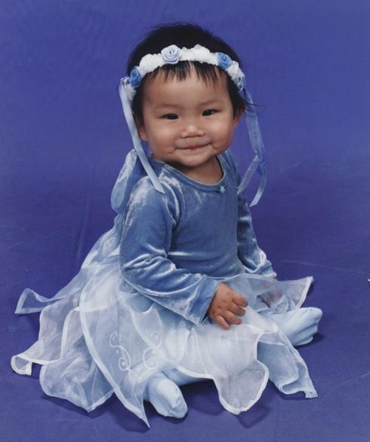
My attempts in vain, there aren’t adequate words in the English dictionary that accurately explain how much these past 6 years has impacted me. But future Barons, I hope this inspires you to put your pride aside and dive headfirst into this journey. If you play your cards right, the times spent with your team will be some of the best moments of your life; so, take advantage of every opportunity that comes your way, and wear your Barons jersey with pride.

I will forever be in debt to Barons for introducing me to some of the best people I have ever known and graciously gifting me memories that will last a lifetime. There is no other organization I’d want to be a part of, nor any other group of people I’d want to share my middle school and high school years with. Thank you.

jaidyn wallace #5

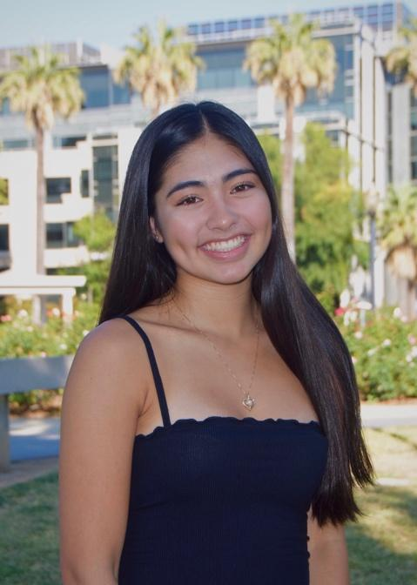
c.k. mcclatchy high school
I’ve been around the Barons organization ever since my sister was asked to play on the 2018 team. I would hang out with all the families on the sidelines finding ways to keep my 10-year-old self-occupied. As I saw how much fun their team had when I tagged along to pick up on Monday of Barons Camp or watched them hang out at tournaments, I became more and more anxious for my turn. Then 6th grade came along, and I finally had a team of my own. I was so happy to no longer just be part of the siblings club.

I knew Barons was going to be something special but what I didn’t know was that in the next 6 years my teammates would become my sisters. I got extremely lucky with these girls. You will hear over and over again from all of us how well we get along— no drama, no fights, no problems. We all just simply enjoy each other’s company and love being together on and off the court. There is truly never a dull moment, and we’re always excited to be reunited once again.

The memories we have made together are ones that are forever ingrained in my brain. I will never forget Nikki falling in the shower at Barons Camp, Nat screaming at our obnoxious neighbors in Newport Beach at 7 a.m., Kayla’s iconic, soda-induced burp, Paige’s feet dying after 12 hours at Disneyland in vans, Reba and Rena going to their rooms early to do homework, Jen always going hard at the socials, whether they sucked or not, and Nicole’s constant fangirling over the twins. Having a group of girls like this is so rare and I am so lucky to be a part of it. The girls who stand by my side today are the same ones who have been here since the beginning and because of that, our chemistry is so genuine. It’s crazy to say I can already write down 8 names on the list of people who will be at all of the big events that are to come in my life. And not only do I love these girls, but I love our families, who have always gotten along so well, and collectively embody the word family. A huge thank you goes out to all the families, especially my parents. You have all dedicated so much time, money, and effort into making this experience so amazing for us, and I cannot thank you enough for what you have put in.

This whole experience would not have been possible without the significant efforts of Coach Bryan. He plans out everything so smoothly that I never realize how much planning things really take. Our annual summer road trips, party bus excursions, going to watch our teammates play, eating as a team, events or meetings, fluid communication— all can be credited to Coach Bryan. These trips and these little things that we do as a team have enhanced my experience and made our team just that much closer.
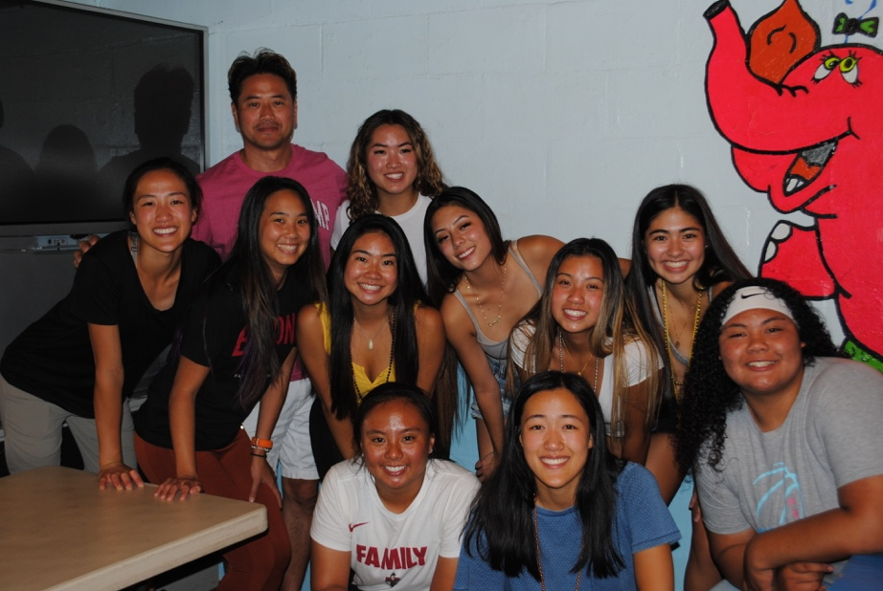
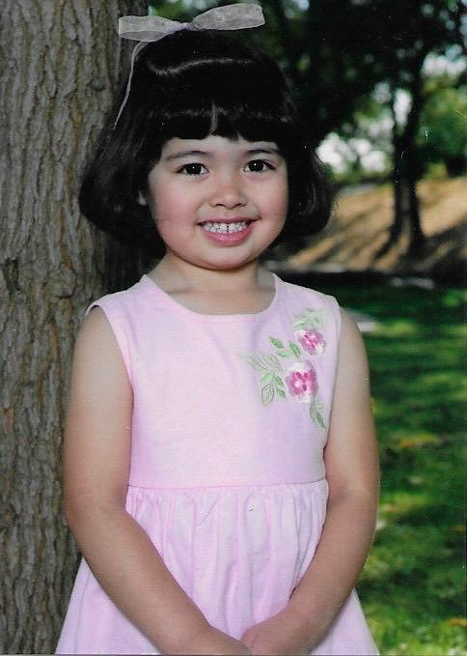
Our coaching staff has also made my experience one of a kind. It’s crazy to think how long ago it was when I first walked into the gym and heard Coach Kimi yell so loudly, so effortlessly. She has really made the effort to stay around our team ever since 6th grade and has watched us grow from little girls into young adults. Throughout these years, she has served as a coach, a big sister, and a role model. Coach AJ stepped in even though he thought he was done coaching, and we are very lucky that he did. I am grateful to be the second Wallace who has had the privilege of playing for him. He’s constantly making teenage jokes that will make us cringe and laugh at the same time and the way is he always enjoying himself is so contagious. I don’t think I realized how much I appreciate Coach Brandon until he stepped back this past year. He has provided me with wisdom like no one else has and I can definitely say he is one the coaches I have the most respect for. He has watched me continue to develop from my scrawny, scared 7th grader self and I am grateful that he has never given up on me, but instead mentored me along the way to get to where I am today. I’m so thankful for how much all of our coaches have been able to help me develop throughout these years. I have been blessed with the most amazing coaching, managing and team dynamic and all the pieces just fit so perfectly.
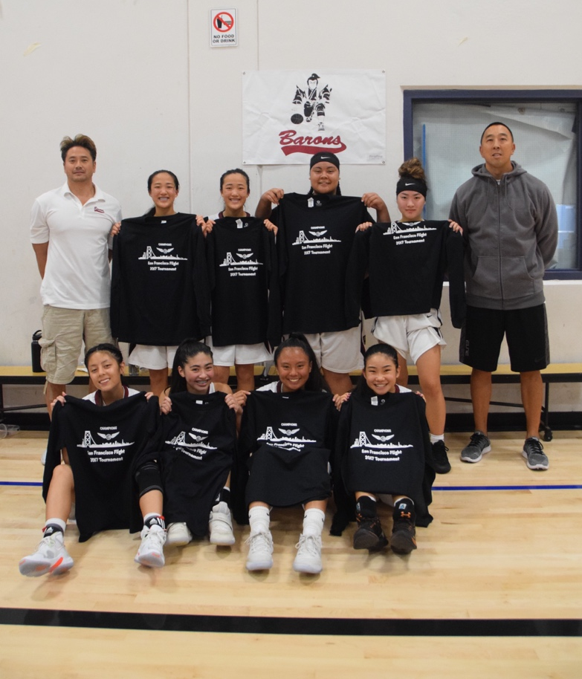
As each year has passed, I have become more appreciative of all that being a Baron truly means. You always hear that it’s bigger than basketball, but you don’t truly understand what that means until you experience it. I can confidently say I have developed numerous relationships, stepped out of my comfort zone, and overall grown as a person. Being surrounded by so many coaches and older players has given me numerous role models to look up to and seek knowledge from, to help me find myself as a player. Looking back through the years, I can see how much I have matured and how this experience has had such a huge impact on who I have become. The bonds that I have formed through this experience are ones I hope to keep for the rest of my life. I am definitely going to miss all the aspects of Barons, but I will forever hold onto the memories and connections I have been lucky enough to make thus far.

Jennifer wong #7

c.k. Mcclatchy high school
I became a part of the Barons organization after my oldest brother played on Barons years before. I started my Barons journey in 6th grade as a “baby Baron”. I wasn’t sure how the whole experience would turn out. When attending the first few practices, I saw a bunch of familiar faces and some old teammates from church league, which brought me a lot of comfort and familiarity. During these early years, I began to create the foundation for the numerous everlasting friendships and bonds that would continue to grow in the next six years.

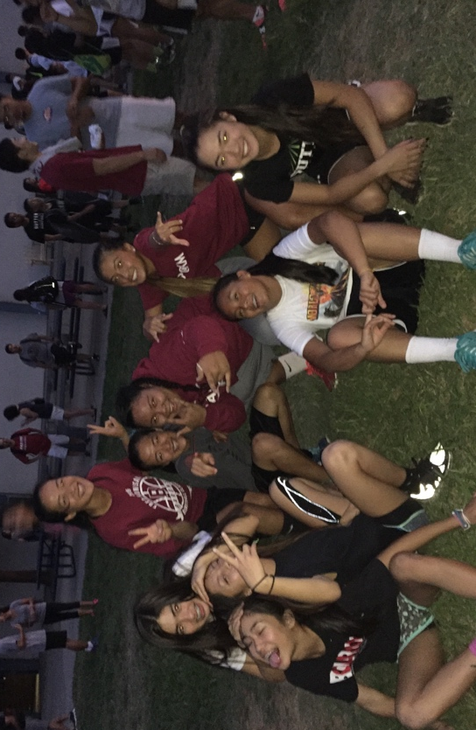
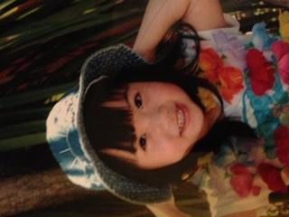
These past years have truly been amazing, and I wouldn’t ever want to spend them without my Barons sisters. We have truly been through everything together. The ups and downs on and off the court. Through every situation we always stick together. Which brings me to the word that I believe embodies what it means to be a Baron: Family. I am beyond thankful for my Barons family and the unbreakable bonds that we have created and maintained. Our team chemistry was what made our journey together so special. Although our team was super competitive, we still managed to have fun while playing. Win or lose, every game was a learning experience that we could apply on the court or to our daily lives. It has been a blessing playing with these girls and they have made it an experience that I will never forget.

To the Barons Organization and Coaches:
My journey would not have been possible without you all. I have received support and insight that is applicable in our daily routines. Barons Camp has always been such a fun weekend for me. Not only do I learn the importance of the close-knit aspects of a team, but I also learn how to expand my comfort zone in so many ways at camp. The Barons Organization puts so much hard work and dedication into everything they do, which is why I was able to have such an enjoyable Barons experience.

To my 2020 Lady Barons:
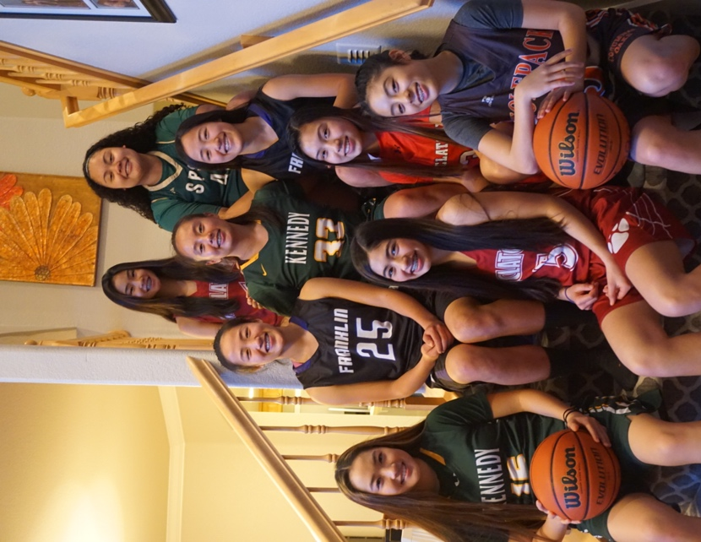
We are now at the end of the road. These six years have gone by quicker than I had hoped. You girls will always be the sisters I never had. I am thankful for the countless memories we have made over the years: the annual girls’ road trips, the team dinners, the tea spilling sessions, and numerous fights to take home those championship t-shirts. You all have impacted my life is such a great way. I can’t imagine spending my Barons journey with any other team. You all are truly amazing human beings and I cannot wait to see what the future has in store for you girls.

Nikki tanaka #10

John f. Kennedy high school
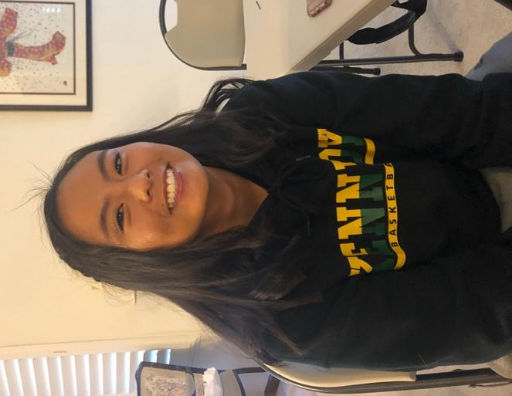
I’ve loved playing the game of basketball ever since I was two years old and I had this small rubber basketball that I would bounce constantly. When I got a little older, I would play catch with my Dad in the living room every night. Basketball has always been my passion and will always be my passion. As I got older I could not wait to play church basketball because we played actual games. From playing church basketball against these 8 girls over the years, I never knew I would be playing with them on the same team. I am so grateful to have played with them for the past 6 years and wouldn’t want to experience my Barons journey with any other team or group of girls. When I first got asked to be part of the 2020 girls team, I did not know what it was like to be a Sacramento Baron and now I learned so much throughout the 6 years that it will stick with me throughout my whole life.

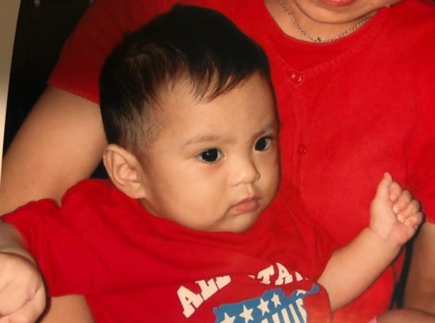
As an eighth grader, I never knew that my Barons journey would come to an end. When I saw the seniors up in front of everyone doing their skit and giving their senior speeches at Barons camp saying their Barons journey went by like a blink of an eye, I thought that could never be possible, but here I am today, a few days after my last Barons camp as a camper and I can’t believe how the years went by so incredibly fast. This Barons journey has been truly the best, I would not have wanted to go through it with anyone else, but the 8 girls that were on my team. I have many great memories with all of them that I will keep forever such as having deep talks in LA, going to the boys games during tournaments in the Barons bus that coach Bryan would take, and going to the mall almost every tournament, those are just some of my many memories I have made with this team. Being a Baron is not only about building great friendships with my team, but meeting other Barons from different teams, both older and younger. I have many great memories at camp such as roller skating, bowling and doing many relay races, those are just some of my fondest memories that will last a lifetime. Being a Sacramento Baron is not only about playing basketball, it’s much more than that, it is about making lifelong friendships and learning lifelong skills that I will take with me well into adulthood.

I first want to thank Coach Bryan because he was the one who asked me to be a Baron and I would not know what I would have done if I ended up playing on a different team. He also was the team manager and the one who would organize team outings such as going to Santa Cruz for a couple days or going to LA and Disneyland.
Second, I would like to thank my parents because I wouldn’t have been able to play basketball or go to tournaments or go on team outings if it wasn’t for them.
Third, I would like to thank Coach Brandon, Coach Kimi, and Coach AJ for believing in me and pushing me to be the best possible player I can be. They played a major role in my experience of being a Baron and they made sure we had fun, but also was competitive to win many tournaments.
Fourth, I would like to thank all 8 of the girls on my team because we clicked well, and all got along. We all have different personalities, but we all had the same goal. And the goal was to leave it all out on the court every single game and if someone was not having their best game, we would keep encouraging them to keep working hard.
Lastly, I would like to thank Rod and Merv because without them, this Barons organization would not be here today, and we would not be able to experience Barons camp and become all one big family. Being a Baron means so much to me and I am so grateful that I am part of this family. Barons. Family. Together.

reba sy #14

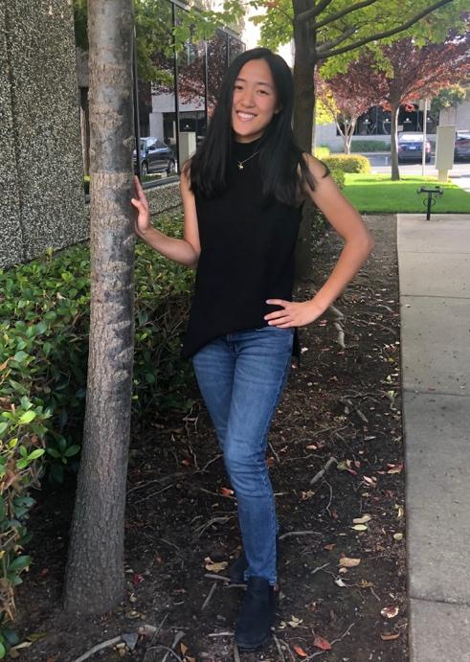
Franklin High school
2014, this is the beginning of my Barons experience. I vaguely remember my mom telling me that there was an opportunity to play with a few teammates from church ball and AAU. To give credit to one person, it was Bryan who introduced me to the Barons organization.

2015, passive. I lack confidence in shooting and dribbling, my enjoyment in playing comes from sharing the ball and being a good defender. The more time we spend together the more I like my team. Also, we’ve become official Barons now!

2016, trying. People keep telling me to shoot more. Coach B tells me that I need to be an offensive threat in order to help the team. This is the first time that I saw my overpassing as a selfish act. Besides that, everything felt right. Our defense was tight, we moved as one unit, we shared the ball on offense, we’ve grown so much... I’m really proud to be a Baron.

2017, scoring. I’m shooting more, the team is relying on me more, we’re doing pretty good.

2018, losing. We’ve reached the plateau Coach B has warned us about, and we had a losing streak, we lost games, focus, and a bit of passion. I have more confidence, I’ve gotten better, I’ve grown closer with the girls and I know we’re going to bounce back.

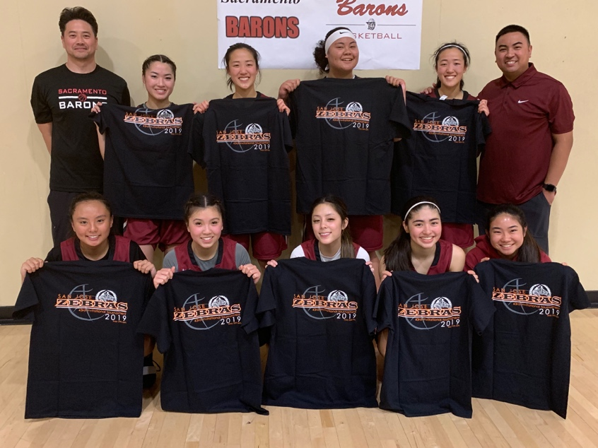
2019, dub. We’ve ended this season on a pretty good note, and I know we’re going to finish our Barons journey strong. Here is my reflection: For me I started out scared and oblivious. Scared of failing, of being open, of leading. Oblivious to how little I knew, to how much I could grow, to how fast time would fly. But throughout these years I had many teachers. The game taught me how to face adversity. My coaches taught me how to be a basketball player, how to be a teammate, how to succeed in life. My aunts and uncles taught me that family extends beyond blood relationships. My teammates taught me to value my time and the people around me.

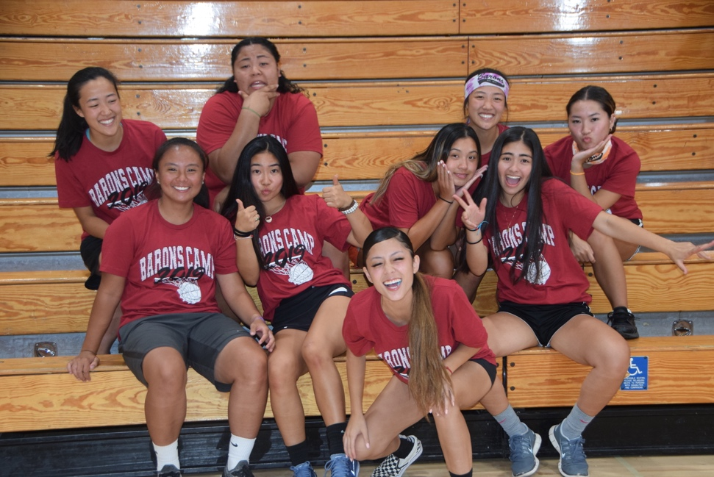
Thank you Coach Brandon, you provided structure and competitiveness that I will truly miss, and your words of wisdom go a mile long in my notes. Thank you Coach Kimi, you’re the older sister that got us together for team bonding activities, that encouraged us, that made us talk, that made us buss our a**. Thank you Coach AJ, for ingraining a bright smile in my memories, for keeping us together, for joining the family. Thank you Coach Bryan, for inspiring me to be generous, for bringing this family together, and for managing all of us (don’t know how you do it). To my girls, thank you for making me laugh, for making me want to be better every day, and for being awesome teammates, friends, and sisters. Our Barons journey has been filled with many ups and downs, we made it to the peaks, and made it through the pits. I’m grateful for having all of you with me along the way.

2020, What is a Sacramento Baron?
Sir, a Sacramento Baron is always motivated, downright dedicated
(yup, especially during practices ;) always)
Our game is tight, good game, good night
(getting older, need lots of rest, water, and mustard packets, night night)
I don’t brag but I ain’t gonna lie, we’re number 1, we get it done son
(“Look at all these asian league teams, they don’t know what’s coming for them” )
Lead what, follow what
(leading the young ones, following the old ones)
Get out of the way, get out of the way, you know
( after all these years, still only know to go straight, full speed; so watch out)
Barons on 3 Family on 6 Together on 9
(1-2-3 go Barons! 4-5-6 thank you Family :) 7-8-..9 bodies 1 heart, love you all)

To future Barons:
Be the best version of yourself
Air-body makes mistakes(it’s all about getting back up)
Rice when u get hurt (rest, ice, compress, elevate)
Obstacles make you stronger
No time to lose (treasure every minute)
Smile, relax, and enjoy the experience

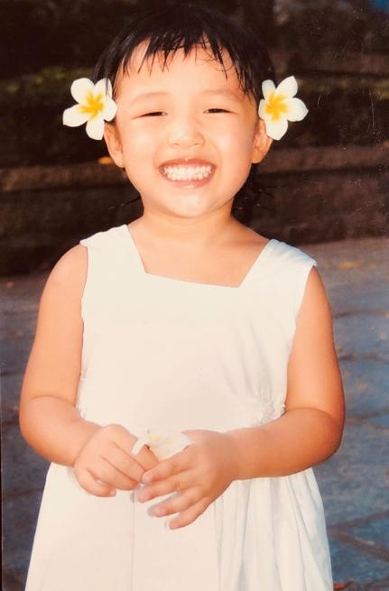
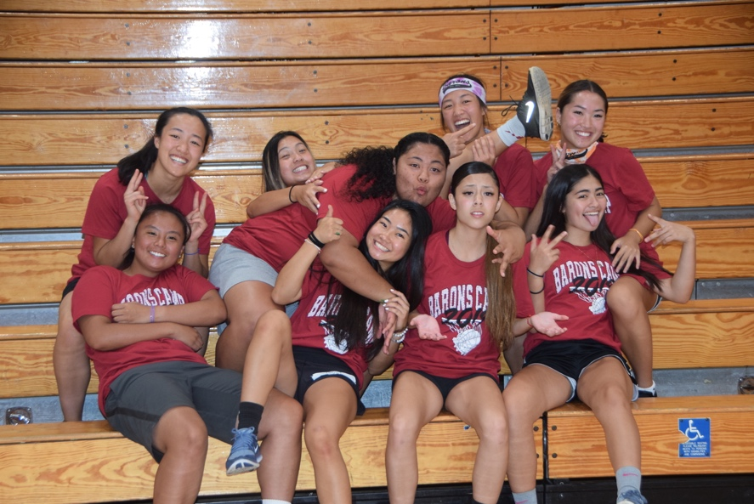

paige onodera #15

John f. Kennedy high school
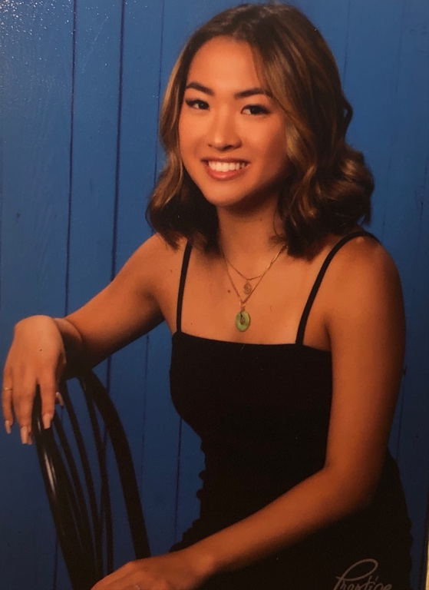
As my time with the Barons organization is quickly coming to an end, I just want to make sure you all understand how much this team and organization truly means to me.

But, first I want to start off by thanking my dad. Thank you for everything you’ve done the past 6 years, I don't say it enough. Thank you for forming our team and choosing such great players and families. Without you, these 8 girls and I wouldn’t be here together. Thank you for coordinating fundraisers and every single trip we took. We wouldn’t have been able to travel to places like Hawaii, Disneyland, Newport, Santa Cruz, and even hopping into the Barons bus to surprise Kayla at her games. Without you, our team wouldn't have made half the memories we share today.

Next I’d like to thank Coach Brandon...not only are you our basketball coach, but a life coach as well. You always preached life lessons and pushed us to never be “satisfied”. I remember freshman year at practice...you huddled the team together in a circle and told us this story…”A warrior came home to see that his whole family was murdered, except his newborn son. The father placed a sword at one end of the room, and a ball at the other, then placed his son in the middle of the two. Although the son didn’t understand...the father gave him the ultimate decision. He asked him, “Son, will you pick the ball or the sword? If you choose the ball, you will join your mother in death. If you chose the sword, you will join me.” The son then crawled to the sword, granting him life. It was the beginning of accompanying his father to fight.

You then turned to our team and asked us that same question...do we choose the ball or the sword? Would we choose the ball and just mess around for the next 4 years? Or choose the sword to go out and compete? Of course, all of us chose the sword. You always reminded our team, to not just be good, but to be great, in whatever we do. (As I can be a spaz and looked zoned out...you see I was actually paying attention!). Anyways, we’ve had positive basketball results under that mindset, over the 6 years we've had 123 wins and 23 losses. That was just one of many examples of how you've shaped our team to never back down. It’s a mentality for success that will forever be applied into our daily lives...basketball related or not. Great things never come from comfort zones...thank you for always pushing us to pick the sword no matter the situation.
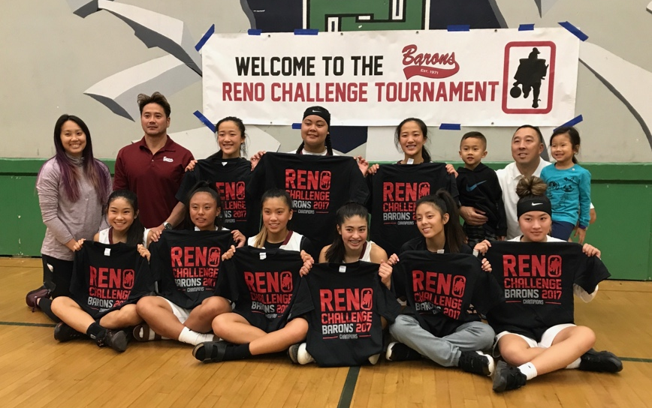
To Coach AJ thank you for stepping in to lead us when Coach B had to take time for his family. Instead of attempting to replace him, you built on what he had already established. No coach has ever called me BIG P, Nicole- Dr. Fong, Kayla-BBQ CHICKEN, and Rena- Coach Rena during real games. Although you love to remind our team at every practice, between every drill, and every water break that we only have one year left, I’m grateful you make all of us cherish and take advantage of the little time we have left together. Thank you for completing our family that has grown over the years.

To Kimi, personally, we have grown closer over the years and I know there has been sometimes, well actually probably a lot of times where we’ve wanted to cuss each other out hahaha. You could be screaming at me one minute but hugging me the next. No matter the reason, at the end of the day we both know it’s all out of tough love. Thank you for being a big sister to all 9 of us and making us show our true competitiveness. Through all the team bonding exercises you set up, boba runs, facetime calls, and lunch dates...you are one of the reasons why our team has grown so close over the years.

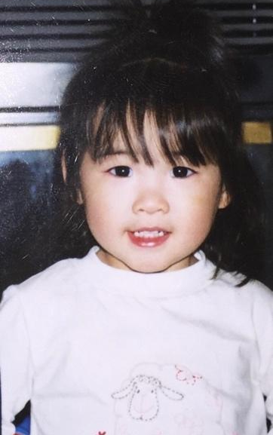
And to all our parents...thank you for all the time, love, care, money, and dedication spent on us... from traveling to tournaments, to fundraising, and even making sure we had enough mustard packets for each game. I couldn't be more grateful to say we are one big happy family.

To Rod and Merv, thank you for making my Barons experience possible. Because of your top priority to make every team part of the Barons family, I've created memories and friendships that will last a lifetime.
Lastly…I'd like to thank my sisters. All 9 of us are original players from the day this team was formed. We’ve won together and lost together for the past 6 years. We've had the best of both worlds... not only are we competitive, we also have the time of our lives together. I can't believe we went from being church ball rivals, to becoming teammates. This ride has been almost too smooth...we are by far the most unproblematic team I know. Not once have we ever had any team drama or disagreements, it's only love, and that's pretty rare. We’ve gone through the worst and best of times but still remained side by side and hand in hand.

Jen, Kayla, Nicole, Reba, Rena, Nikki, Jaidyn and Nat. I love you guys so much. I don't say it nearly as much as I should. I’m so glad to call all 8 of you my sisters. There's no other group I’d rather hoop with, travel with, stay up till 4 AM with, get calf cramps with, and love. If I could go back in time, I’d do it all over again with no hesitation. When we go our separate ways in less than a year, I know every single one of you have a bright future ahead. I’ll always be supporting each of you through every achievement, and every obstacle along the way. No matter how many miles apart we are, our Barons family we established is always with us. Like Rena said, “There's 9 bodies but 1 heart.” I wish this team could last forever, but all good things must come to an end. Change is inevitable, but our sisterhood will last for a lifetime. I love you guys. Thank you.

rena sy #25

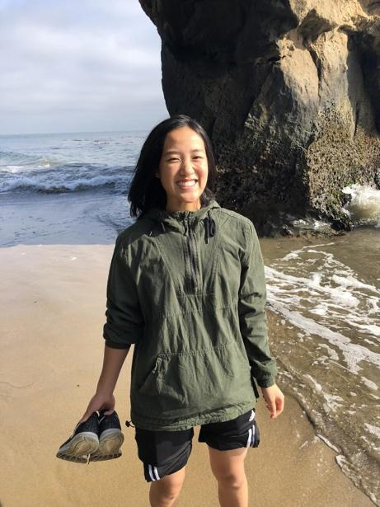
Franklin high school
“With the 9th pick in the 2014 Asian League draft, the 2020 Sacramento Barons selected…” me. Back then, standing at an impressive 4’8”, all I knew was that I loved to play basketball. Six years and only 7 inches later, I know I love my teammates, for they were one of the brightest lights in my life. We weren’t the best players or the biggest stars, but we were one hell of a team. Thinking back, of all the things my mom made me try, Barons is the best thing she ever signed me up for.

I played basketball and I did so much more. I became friends with the most amazing group of individuals. I got the coolest older sister. I was coached and mentored by one of the greatest coaches of all time. I laughed at the most ridiculous things. I smiled at the smallest things. I had the time of my life.
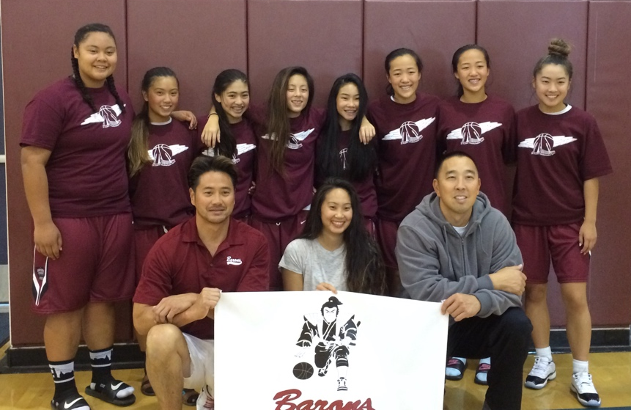
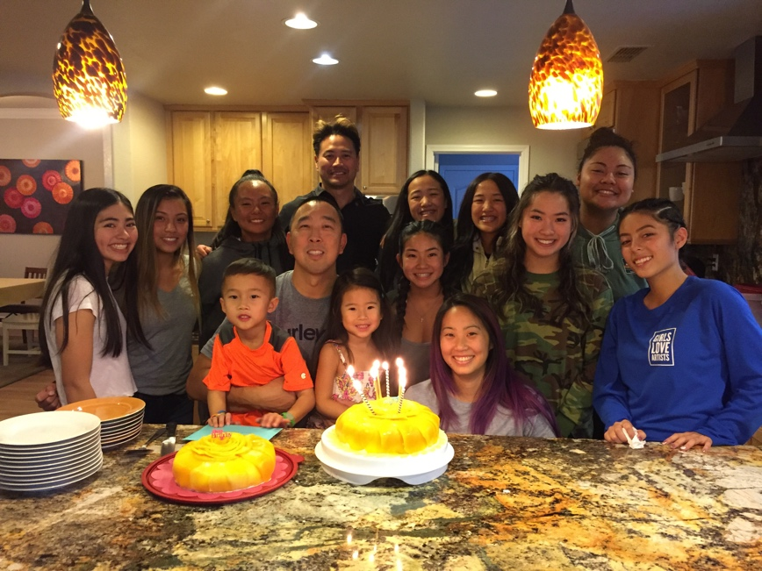
It took some tough losses, much sighing from our coaches, much frustration in our own hearts, many long sweaty practices, and some unforgettable wins for us to become the team we are today. It was six short years full of memories that I will always treasure. If I had a photo book of these past years, the same laughing faces making me smile since I was 12, would be the highlight of every album. No one else could have made these last few years as special as you all did.

To the people who are in my warmest memories, who made being a Baron so meaningful.
Coach Bryan, thank you for bringing together this team that became my family. You are hands down the most giving person I know. You taught me that sometimes it’s not about what you can get out of something but what you can put into it. You were my inspiration to be selfless, to look out for others first, to be a better me.
Coach Kimi, thank you for being the older sister we needed. You were always there to cheer for us when no one else would, to wake us up more than coffee ever could, to make us smile, to make us laugh, and to make sure we never slacked, never gave just second best, never quit when things got tough.
Coach Brandon, thank you so much for everything. As a player, I learned how to succeed on the court. As a student, I learned how to succeed in life. You taught me to be a fighter, to be a teammate, to do everything with a purpose, to do the little things, to have high expectations for myself, to treasure the people around me, because letting go can be so difficult, to listen when “old” people are trying to teach me because everything, or at least 99% of what they say is true. You were always more than a basketball coach, you were a mentor, an inspiration, and someone I am so grateful I had the chance to meet.
Coach AJ, I think we found the only puzzle piece that could have fit. You made us laugh, you made sure we didn’t waste the little time we had left, you made us focus, you gave us our first nicknames on the court, you helped us get that W, you came in trying to find your place on the team but you ended up helping us find ourselves and our passion again. It was a short time, but a little goes a long way, and I am glad you became a part of our family.
Reba. Nikki. Nat. Nicole. Jen. Jaidyn. Paige. Kayla. I love you all so much.
Thank you for giving me so many happy memories. Math has always been easy for me, but the equation for friendship and socializing was one problem I thought I would take a long time to solve. But you all became my answer. It was easy to smile, easy to laugh, easy to have fun, easy to be myself, easy to have six years flash by just like that with you all next to me. I’ll miss our practices that were always the highlight of my week, the wins that were always the highlight of my basketball journey, your smiling and laughing faces that were always the highlight of my Barons adventure. I’ll miss seeing you all on the court -your unstoppable layups, your smoked fast break layups, your splashing threes, your infectious energy, your super serious game face, your no look passes, your “here you take it Rena, I don’t want it” moments, and best of all your triumphant faces when we beat the Ninjas. I’ll miss your crazy dances, your ridiculous and hilarious stories, your kindness and willingness to include me, your big brain cells, your unique and infectious laughter, and your 24/7 party energy. Thank you for bringing so much joy into my life. If you were all words in a book, you told the most unforgettable story. If you were all notes on a music sheet, you played the most beautiful song. You made me feel loved and so, so blessed, and I wouldn’t trade our time together for anything. I was born with 1 sister and now I have 9.
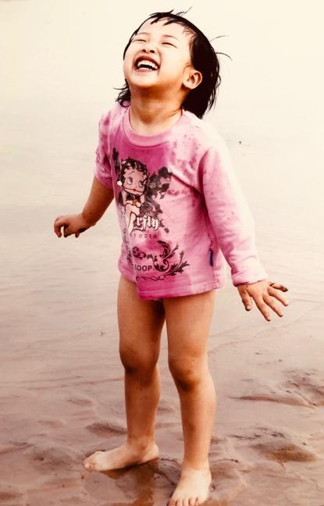
And to all the future Barons out there, what is it like to be a Sacramento Baron? It is being a part of a family that will only keep growing. It is learning to put others before yourself. It is taking a leap of faith and trying new things. It is to have six years of so much fun, so many happy memories, and so much love. It is playing basketball and it is so much more. It is becoming a better athlete and also becoming a better version of yourself. It is growing up, mentored by the many oldies that have walked the same path. It is realizing that you are never alone, you have their backs and they have yours.
Barons. Family. Together.

natalie omega #30

cosumnes oaks high school
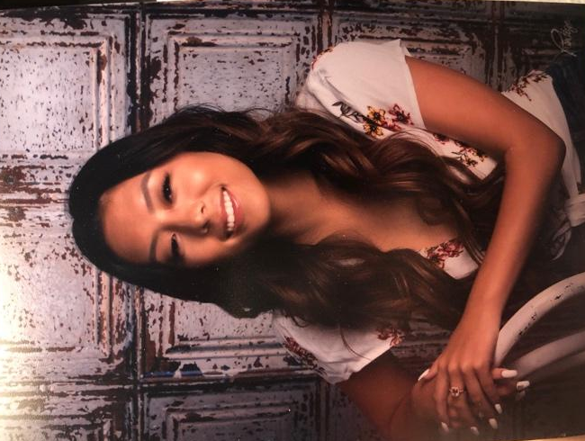
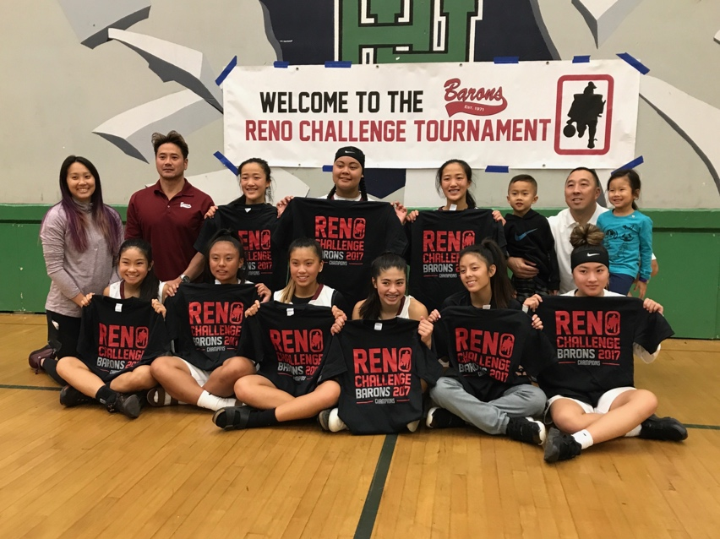
My Barons experience was one I will always remember. I remember the day Mr. Onodera called my dad asking me to play with the Barons while I was in the passenger seat excited and nervous. I grew up knowing of all these girls but I never personally knew them because they all played for the other church teams while I was by myself. I still remember the first practice with Coach Kimi and Kirsten and I never imagined seeing myself so close with everyone on the team, including all of the other grades playing Barons. I love how the girls became my sisters and the parents and siblings became my extended family. On and off the court we were always close and picking each other up with no drama between anyone. My years with them has gone by so fast and I will always cherish the memories we created, the good and the bad, and I will always be in touch with everyone as I have made life-long friends. The Barons organization has taught me life lessons and their values that I will carry with me from here on and all of the Barons Camps I will remember and retell the stories I share with everyone I met and coaches.

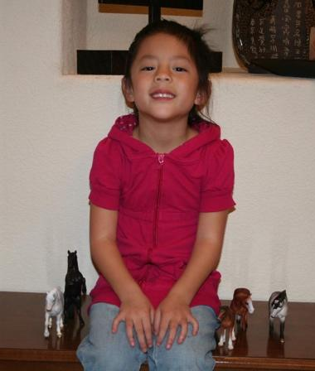
To my girls, I want to thank you all for being supportive and my best friends. I also want to thank you for making me feel a part of the team from the second I walked into the gym for our first practice. It honestly felt so cool to be playing with the girls that kicked my teams butt in church ball, lol. I will always cherish the memories we have made throughout the past years and I hope to go on summer trips with you guys even though we may be parting ways. Near or far you guys are my support system and my sisters. I love how we only got closer and we can sing the night away when we are together. We may be continuing our lives away but always feel free to text me and hang out whenever, because I’m a phone call away. I wish you all the best after high school, I hope to see you pursuing your dreams and being successful and happy with anything you choose to do. I’m so proud to say I was a 2020 Lady Baron with all of you, I love you all!

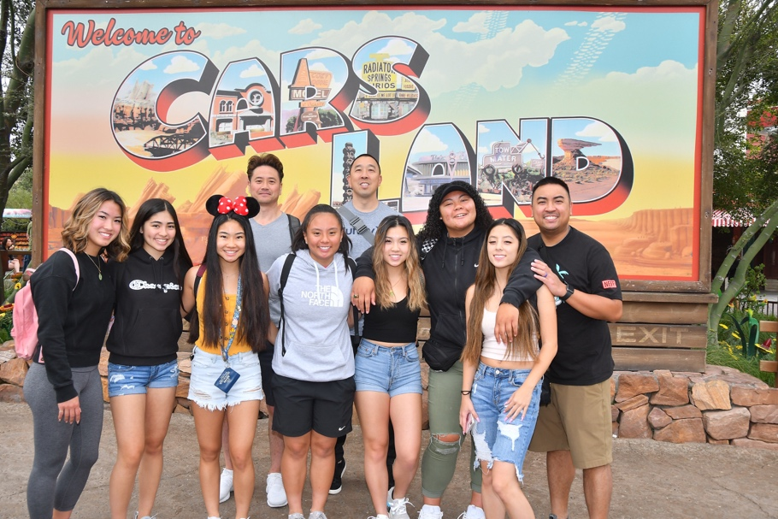
Also a big thank you to Coach Brandon for his time and commitment for our practices and games and for bringing Maddie and Jackson who makes great plays for us. Thank you Coach Kimi for yelling at us girls when we need a push to execute our game and to push us to become better. Thank you to Coach AJ for continuing what Coach Brandon had started with us and finishing with us. Thank You to Coach Bryan who has done so much for my team and I from surprising us to Kayla’s game and going on really fun summer trips with my girls. Lastly, thank you to the Barons organization for creating an amazing organization that I am very lucky to be a part of.

kayla revelo #55

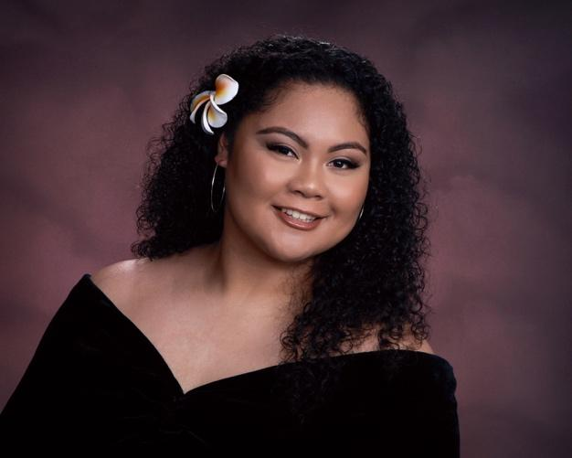
St. patrick’s st. vincent’s high school
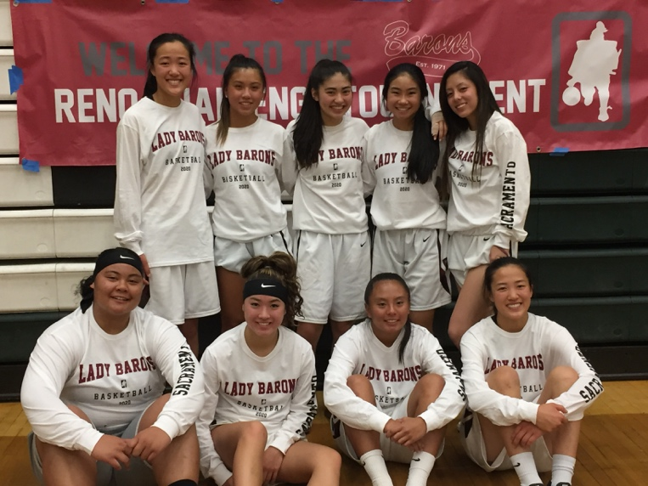
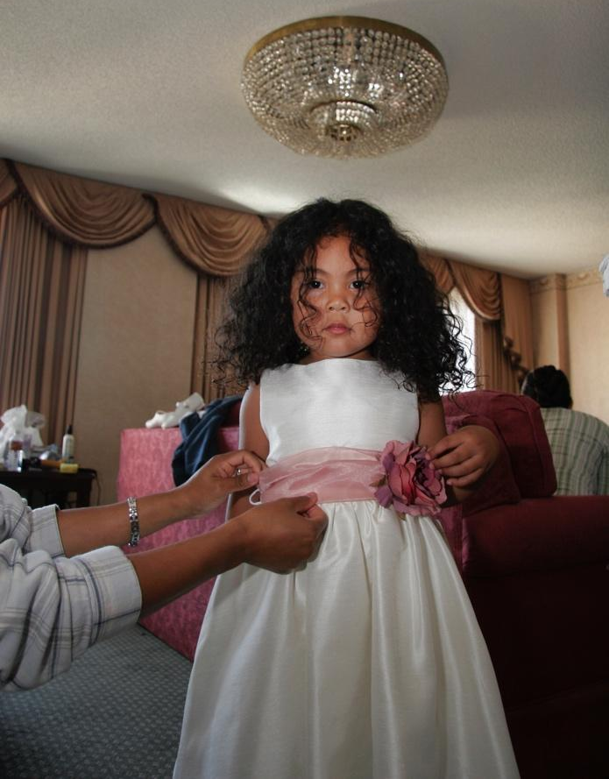
Being asked to play for the Sacramento Barons in sixth grade was probably one of the best memories I can remember. It started with me at a free throw contest in Sacramento and I had to go against Jen. Our dads started talking and Jen’s dad talked to my dad about the Barons. From there it’s history. I was so excited to play for another basketball team, but I was also scared, because I knew literally no one. I was from the Bay Area and all the other girls were from Sacramento. They already had chemistry with each other, but once I came to the first practice, they welcomed me with opened arms, already accepting me as if I had already played with them. In the sixth and seventh grade, we were called the Warriors, and I thought our team was like super legit because we were super competitive and hungry for the game. I remember whenever we had a game, I would always hear “Oh we got this, they hella small,” (well except for me) but they always underestimated us. We would blow teams out by so much by our speed and aggressiveness, and I remember thinking to myself, “wow I love being on this team, no one can stop us!” Continuing to play with the Barons, I got much closer with the girls and strengthened our bonds to where I can now call them the sisters that I have always wanted. Getting closer with Coach B, Coach Bryan, Coach AJ, and Coach Kimi has made my Barons experience so much more memorable. Because of them and their great coaching, I have become a stronger and better basketball player from when I was a basketball player in the sixth grade.
Overall, I want to thank Coach Rod, Coach Merv, and Coach Rich for creating an amazing organization that I am proud to be a part of and for making my Barons experience much more memorable with having Barons Camp and all the other great things you guys make possible. Thank you to Coach B for the time and effort you put in to coaching the girls and I. You weren’t just a basketball coach, you were also a life coach, and because of that I have become a better person. Thank you, Kimi, for not also being a great coach and motivator but also an older sister. Thank you, Coach Bryan, for all the tips you give me to have a better game and giving all the girls and I rides to places in the Baron-mobile. Thank you, AJ, for stepping up to help coach us when Coach B wasn’t available. I’m grateful that you actually didn’t replace Coach B, but you helped me and the girls continue to build up and strengthen what we have already created. You kept us together and on top of that I will never forget the greatest nickname that I have ever got.... BARBECUE CHICKEN! Lastly, I want to thank the girls. Thank you, Nicole, Rena, and Reba, for all the positive vibes you always give no matter the time or place. You always know when to put a smile on my face and pick me and the girls up when I am down on court or just in general. Thank you Paige and Nikki for making everything always funny, even on the court or even with your stories from school. You two are the ones to always make me laugh. Thank you, Jaidyn, Jen, and Nat, for always being my dance partners at socials and for being the ones. You guys are the ones that know how to start a party. You guys are the ones that help make our outings much more fun with your guys enthusiasm and outgoingness. I really appreciate all of you girls because without you guys, I don’t know where I would be right now. Not only do you guys push me to be a better basketball player, but you guys push me to be a better person in general. These past six years have been the best years of my life because I was with you. I love you guys so much. BBQ CHICKEN IS OUT! ✌🏽😚

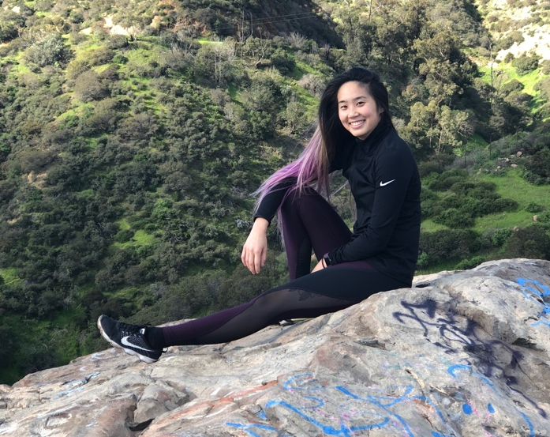
Coach Kimi nakamura
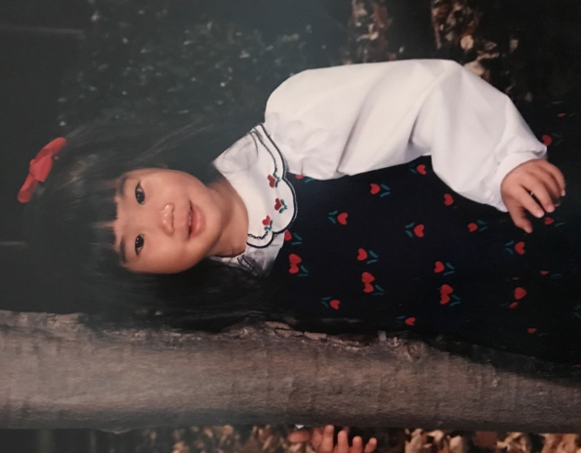
Ten years later, it is my barons team reunion and the girl’s senior year. What an incredible way to end our last Barons tournament together. It has been an amazing journey as a Baron, first a player and now an assistant coach. I am truly grateful for the opportunity to be a part of your lives as well as your families. It has been an amazing journey, being able to watch you grow as players and as young ladies. Additionally, I want to thank you girls for welcoming me as your assistant coach and still allowing me to do so despite me being away. I can’t believe this will be our last Barons tournament together but look forward this last season. I hope to see you girls at your ten-year reunion, laughing and reminiscing on old times. I do and will continue to miss you girls, especially the yelling part ;). I’m kidding! Good luck and you know I always have your back.
I also want to thank the parents for trusting Brandon, who trusted Kirsten and I to coach your girls in their first tournament. I am so grateful for such a loving and supportive group of parents. Just as I do the girls, I continue and will continue to miss seeing you all at tournaments and team outings.
Thank you Brandon for giving me the opportunity to coach these girls and continue to watch them grow. Thank you, AJ, for still allowing me to assist you whenever I’m available. Lastly, of course, thank you to Bryan and Elaine for all your support and love. You are an amazing duo and I appreciate everything you’ve done for the team and me.
I love you all and can’t wait to finish the season strong! Once a Baron, always a Baron.

Coach Aj Fajardo
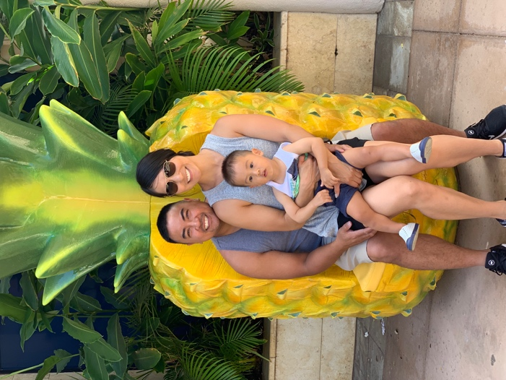
Although my time with the Barons 2020 team has been short, my family and I immediately felt welcome by all the girls and all of the families. Coaches Brandon, Bryan and Kimi have done a great job with the team throughout all the years and I am thankful to have the opportunity to coach this great group of nine young ladies who make up to be one amazing team.

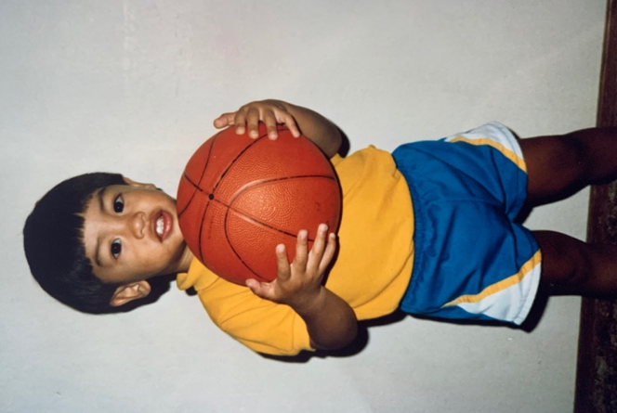
From the start, I wanted to make sure I continued to build on the solid basketball foundation that the team already had. I still remember my first practice with the team on March 5, 2019. As I told them then and “kindly remind” them every-so-often, our time together will go by quickly so we should “value our time.” Overall, my time with the Barons 2020 team has been a great experience and I know our senior season will fly by as well.

To Coach Brandon: I am forever thankful to have always been learning from you, on and off the basketball court. To Coach/Uncle Bryan: thank you for all your work for the team and for our Barons families. To Coach Kimi: thank you for being there for the girls, in any capacity that you could give. To the Barons 2020 families: thank you for all your love and support for the team! To the girls: I am appreciative that you have allowed me to join your Barons 2020 journey and am really looking forward to our senior year. Also, I am excited to see what lies ahead for all of you after high school. Always remember to value our time, be great teammates on and off the court, and strive to be the best versions of yourselves. And don’t forget…bubba!

Barons. Family. Together.

